Data Loading to Mong DB from Open AQ

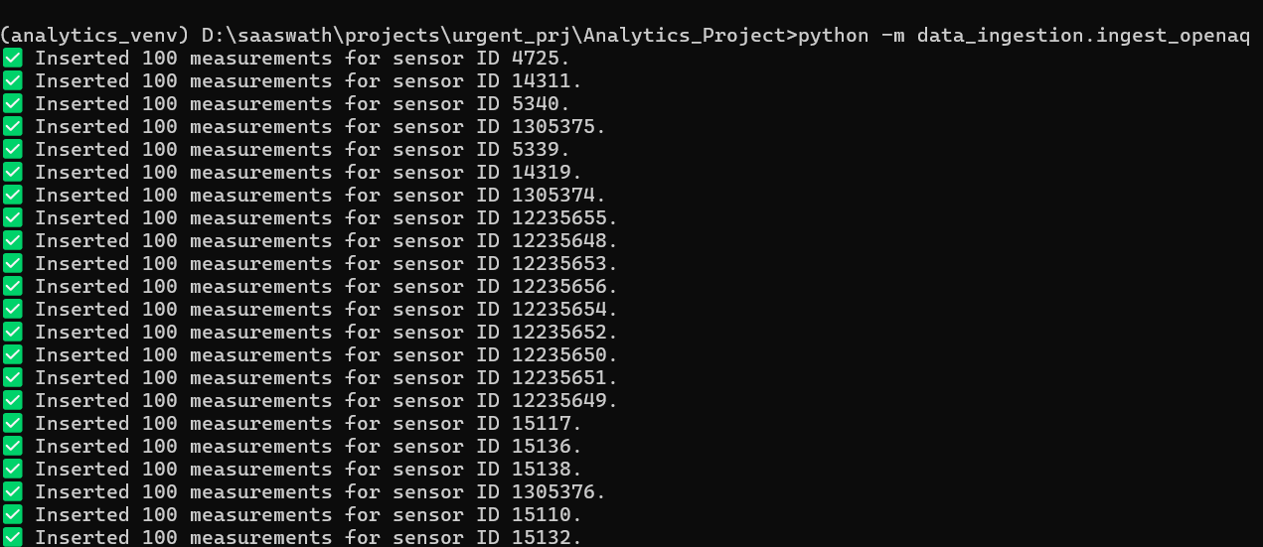

Running ETL Process and saving that to PostgresSQL



Training IsolationForest Model from Postgres

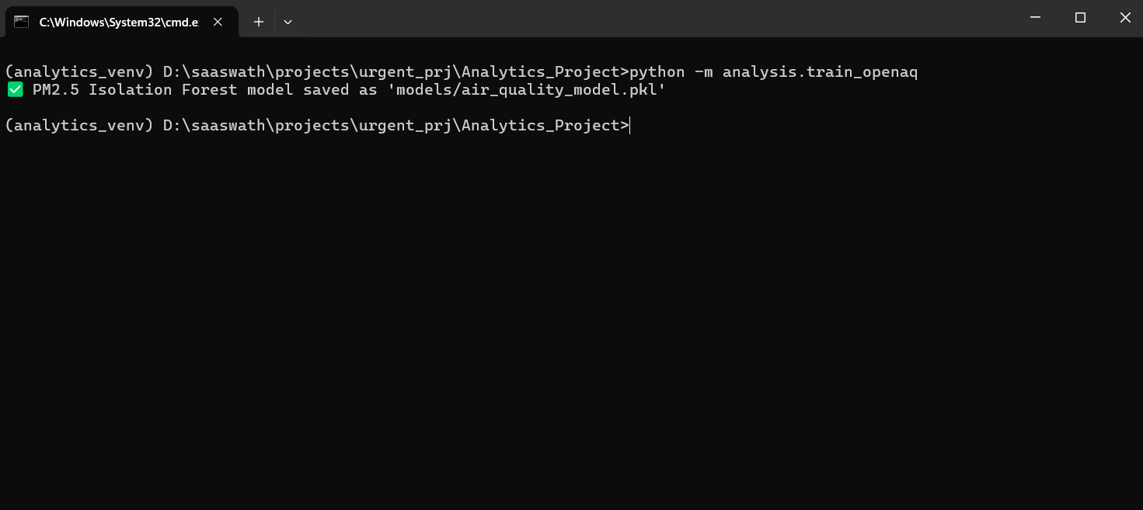

Running a Visualization Application using Flask

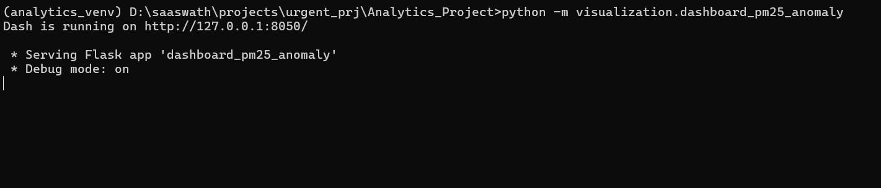

Final Visualization

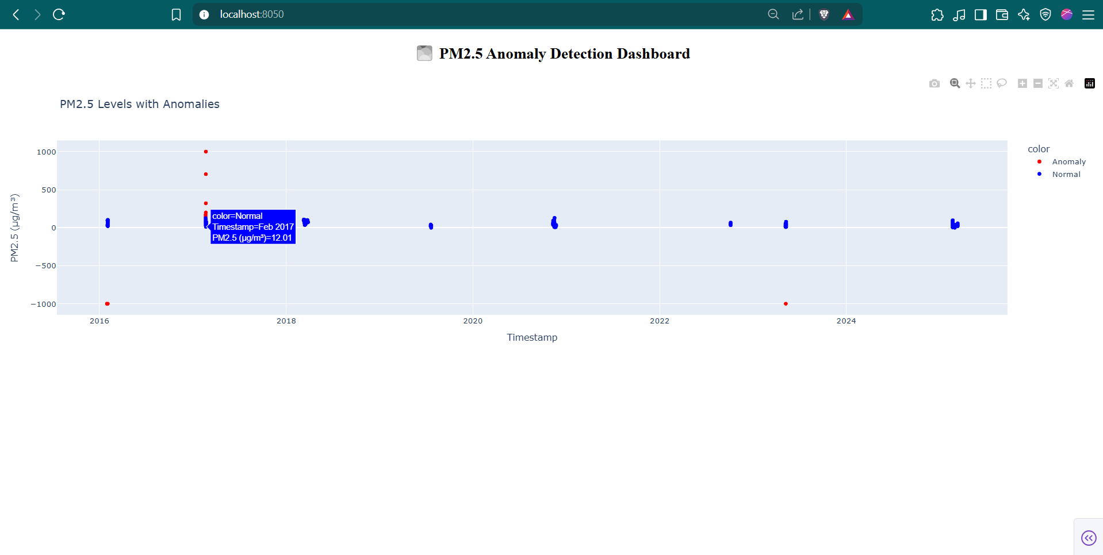

Data loading to Mongo DB from open Meteo

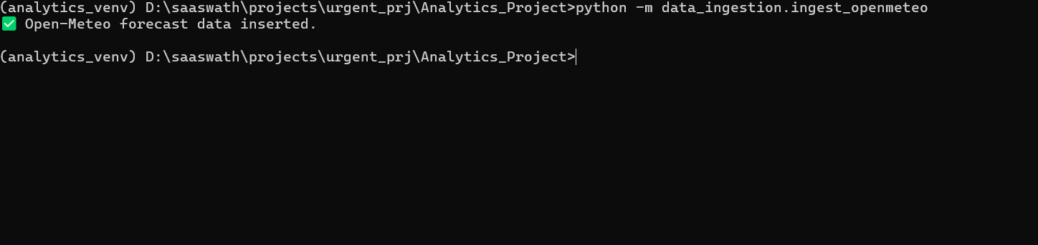

Running ETL Process and saving that to PostgresSQL

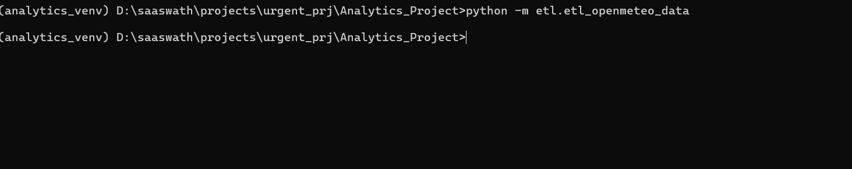

Training ARIMA Model from Postgres



Final Result

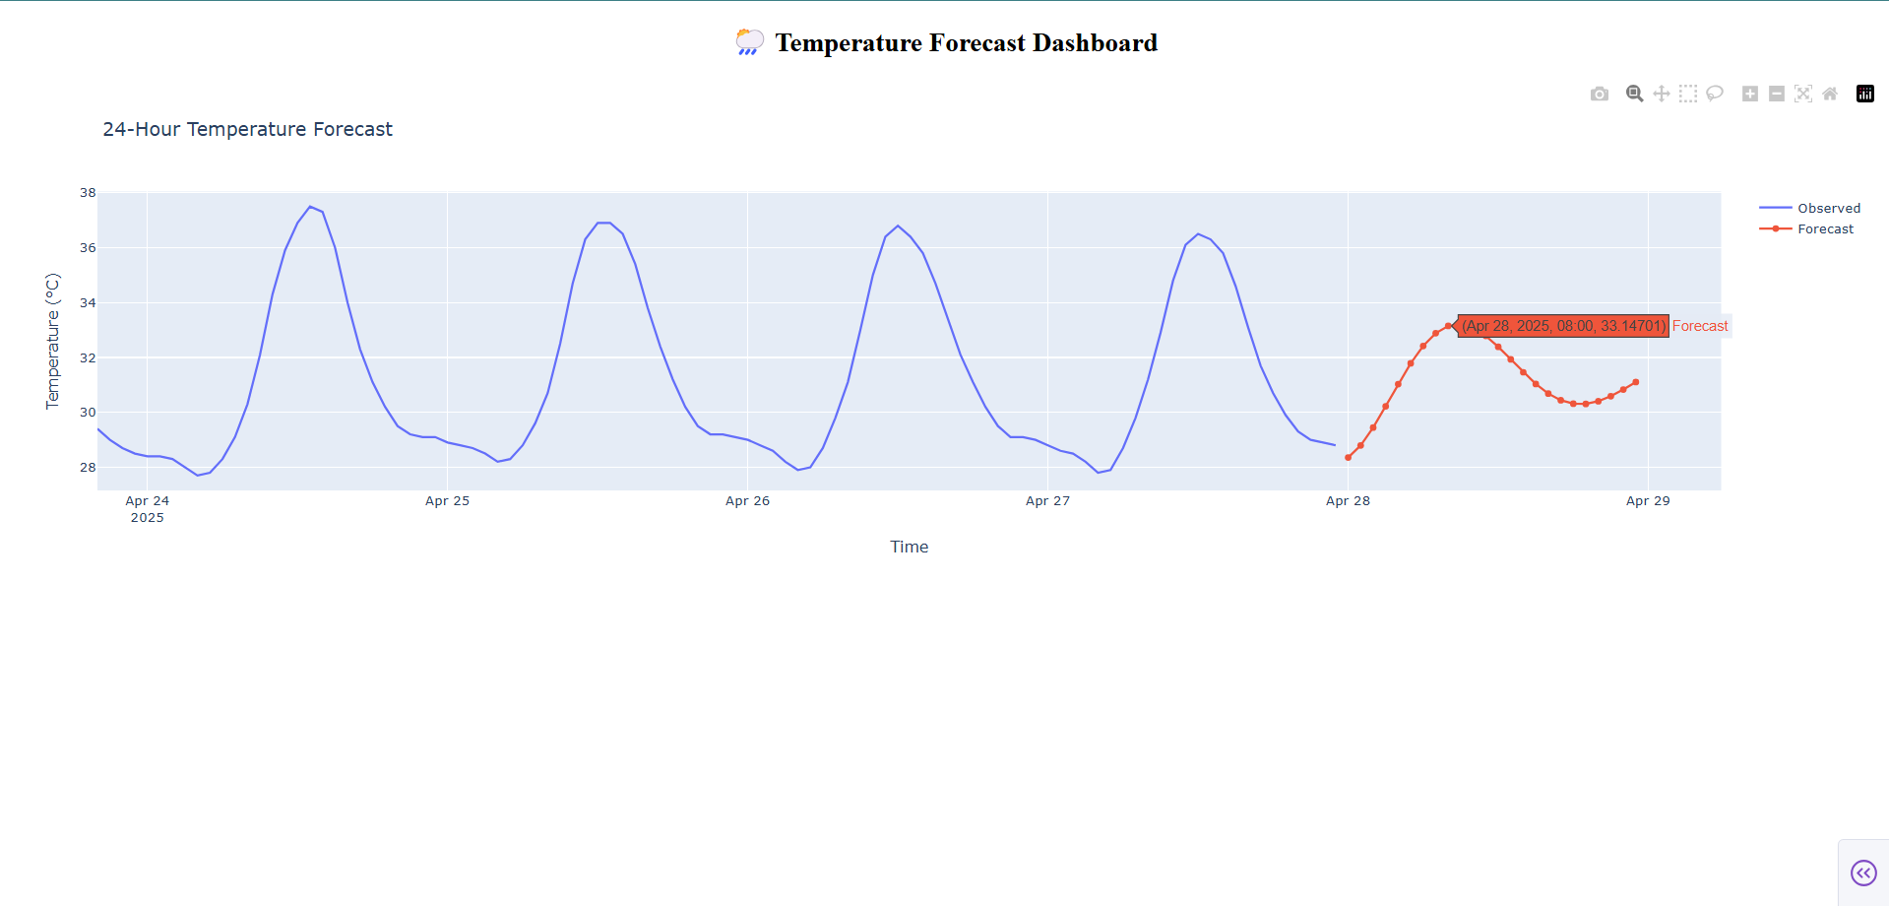

ETL for World Bank

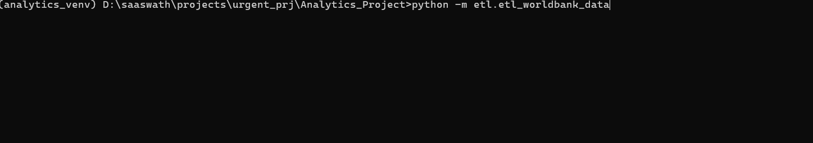

Linear Reg Model For World Bank Dataset



Final Visual

